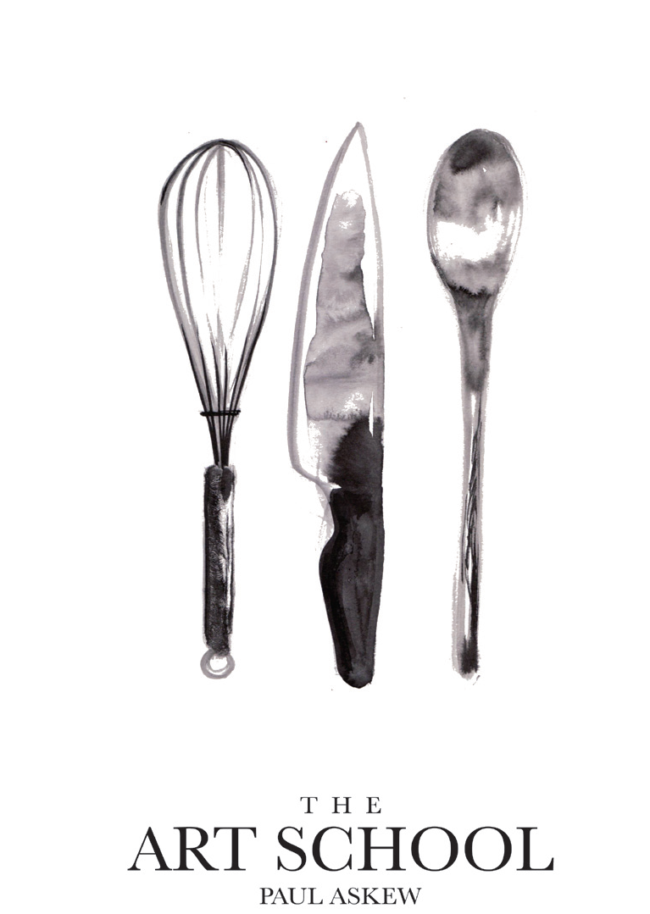
MARKET MENU
Sunday, 23rd May 2021
ON ARRIVAL
A glass of Castorani Aianera Gran Cuvee N.V. & Chef’s snack

Amuse Bouche served with Wirral raw milk butter & Art School breads
TO START
Terrine of free-range Whitchurch chicken, Southport smoked pork, Ormskirk leeks with black garlic,
chicken skin crisp, summer leaves and lovage vinaigrette
-
Grilled fillet of Menai mackerel marinated in wasabi, soy & sesame,
gooseberry puree, kohlrabi and purple kale
-
Seared King scallop cooked in the half shell with Southport smoked pork,
beluga lentils, organic red miso & wakame seaweed butter
-
(V, Vg) Trio of marinated Hooton beetroot: saffron pickled golden,
blackberry & chilli purple & sweet pickle candy carpaccio served with English asparagus,
plant-based soft cheese infused with lemon, chive & black pepper and spring leaves
MAIN
Organic Rhug Estate Duroc pork loin cutlet with Jersey Royal potatoes, summer vegetables,
Granny Smith Apple & vanilla puree and Sage & fermented garlic raw milk butter
-
Pave rump of rare breed Red Poll Bunbury beef with buttered local pink tip spinach,
onion puree, charred Grelot onions, ox cheek & natural jus
-
Pan-roast Peterhead hake with “Pommes Bretonne”, Monk’s Beard,
Wirral watercress and Southport smoked pork crumb
-
(V, Vg) Roast tranche of cauliflower with compressed apple, spring cabbage & chickpeas, asparagus,
Jersey Royal potatoes, wild garlic puree, pomegranate vinaigrette and pine nuts

DESSERT
Trio of signature Art School desserts
Three courses including aperitif & snack £53.00
Optional Coffee and petit fours (£9 per person supplement)
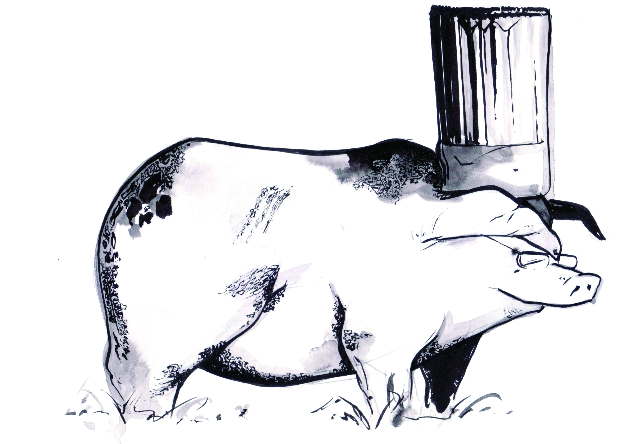
Paul Askew

